Tools for developing a hunch: Fishbone diagram template
This tool is useful to use after completing a 5 Whys analysis tool to identify a problem. Write the problem into the box on the left, then brainstorm all possible causes and group them into categories. Alternatively you could identify from the list of common causes and contextualise to your issue. Common categories include:
Teachers
Students
Curriculum
Instruction (including materials)
Infrastructure (e.g. timetables)
Policies
Procedures
Environment/Space

Add causes with lines branching off from the main backbone at an angle. Write the description of the cause at the end of the branch. These are usually one of the main categories discussed above.
Add details/effects. Details related to the cause or effect may be added as sub-categories branching off further from the main branch. Continue to add branches and a cause or effect until all factors have been documented. Once the diagram has been completed, analyse the information as it has been organised in order to come to a solution and create action items. Which of these reasons can you have an impact on through teaching and learning design?

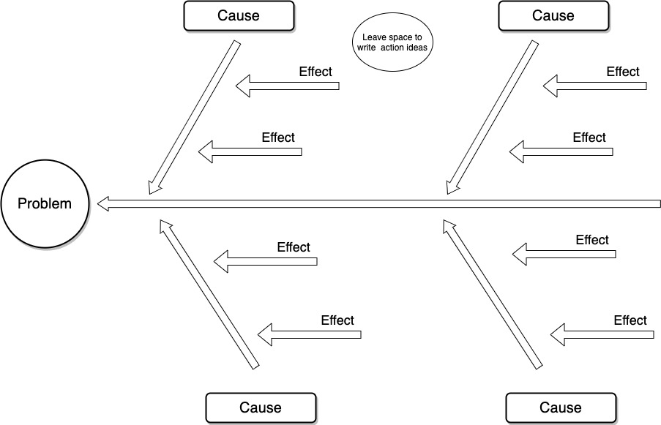

Below is a worked example of the fishbone diagram that analyses the problem of students’ overreliance on the teacher for next steps. On the next page, there is a blank template for you to print and use yourself.

